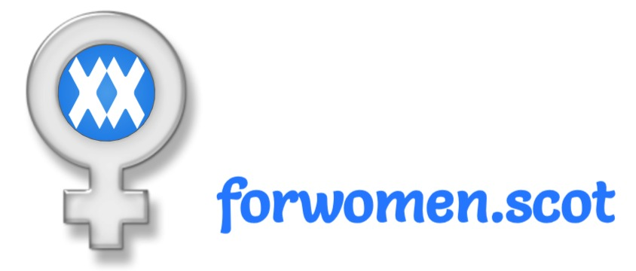

Did you know that the Scottish Government

is planning a law to allow ***any*** man to

self-declare himself to be a woman?

Come join us fight to keep women’s and children’s rights and protections.





Did you know that the Scottish Government

is planning a law to allow ***any*** man to

self-declare himself to be a woman?

Come join us fight to keep women’s and children’s rights and protections.





Did you know that the Scottish Government

is planning a law to allow ***any*** man to

self-declare himself to be a woman?

Come join us fight to keep women’s and children’s rights and protections.





Did you know that the Scottish Government

is planning a law to allow ***any*** man to

self-declare himself to be a woman?

Come join us fight to keep women’s and children’s rights and protections.

